UNIT 1: 12M

1. INDUSTRIAL INTERENT SYSTEM

Industrial Internet system:

* The Industrial Internet is the integration and linking of big data, analytical tools and wireless networks with physical and industrial equipment, or otherwise applying meta-level networking functions, to distributed systems.
* The term was coined by General Electric (GE), a U.S. corporation.

Explains Industrial Internet:

* The Industrial Internet incorporates ideas of intelligent machines, or specific pieces of equipment, with embedded technology and the Internet of Things (IoT).
* Examples are pieces of machinery or vehicles that are equipped with intelligent technologies, including machine to machine (M2M) technologies that allow manufacturing equipment or other types of equipment to send data back and forth, or "talk among themselves."
* The Industrial Internet also is applied to transportation projects, such as driverless (or autonomous) cars and intelligent railroad systems.

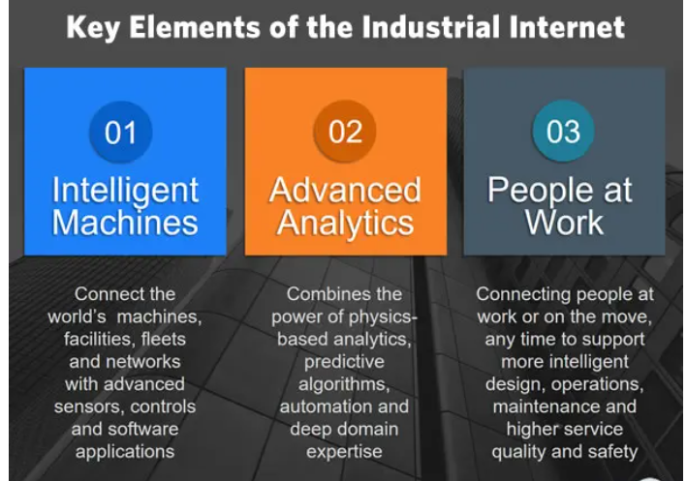

1. INDUSTRY 4.0:

* Industry 4.0 is used interchangeably with the fourth industrial revolution and represents a new stage in the organization and control of the industrial value chain.
* Cyber-physical systems form the basis of Industry 4.0 (e.g., ‘smart machines’). They use modern control systems, have embedded software systems and dispose of an Internet address to connect and be addressed via the Internet of Things (IoT).
* This way, products and means of production get networked and can ‘communicate’, enabling new ways of production, value creation, and real-time optimization.
* Cyber-physical systems create the capabilities needed for smart factories.
* These are the same capabilities we know from the Industrial Internet of Things like remote monitoring or track and trace, to mention two.

**Fourth industrial revolution**

* We are now in the fourth industrial revolution, also referred to as Industry 4.0. Characterized by increasing automation and the employment of smart machines and smart factories, informed data helps to produce goods more efficiently and productively across the value chain.
* Flexibility is improved so that manufacturers can better meet customer demands using mass customization—ultimately seeking to achieve efficiency with, in many cases, a lot size of one

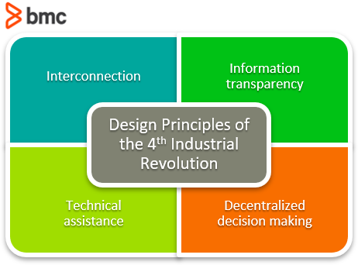

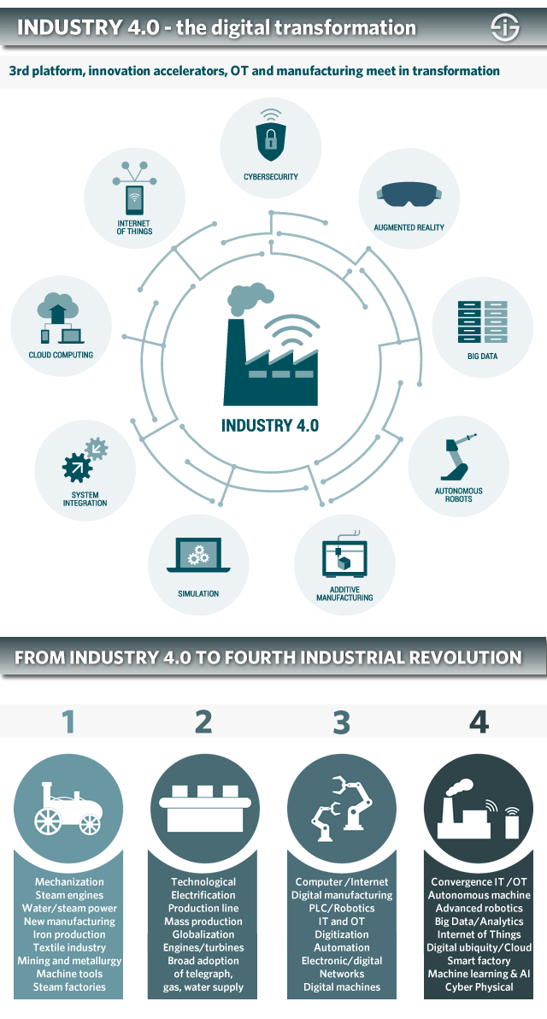

Industry 4.0 is often used interchangeably with the notion of the fourth industrial revolution. It is characterized by, among others,

* even more automation than in the third industrial revolution,
* the bridging of the physical and digital world through cyber-physical systems, enabled by Industrial IoT*,*
* a shift from a central industrial control system to one where smart products define the production steps,
* closed-loop data models and control systems and
* personalization/customization of products.

Industry 4.0 challenges and risks

* The definition of a strategy (for Industry 4.0), challenge number one.
* The rethinking of the organization and processes to maximize outcomes.
* Understanding the business case.
* Conducting successful pilots.
* Making the organization realize action is needed.
* Change management, so often overlooked.
* Company culture.
* A true interconnection of departments.

1. Collaborative Platform and ANALYTICS FOR SMART BUSINESS TRANSFORMATION:

**3.a)ANALYTICS FOR SMART BUSINESS TRANSFORMATION:**

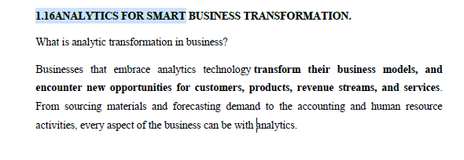

1. **Basic principles of design and validation of cps**

**5.BASICS OF INDUSTRIAL IOT:**

1. **Write briefly about Industrial sensing and actuations.**

